www.artnc.org

Constructing Circles

Writer: Tonya Buff, Math Teacher
Grade Level: 7th grade
Big Picture Concept: Impact, Part/Whole
Subject Areas: Math and Visual Arts
Essential Questions: What are the parts of a circle?
Abstract: Students will construct concentric circles using a compass, then plan and design a piece of art using Frank Stella’s Raqqa II for inspiration. Students will also be able to identify and demonstrate an understanding of the relationship between the parts of a circle.
Duration: 2 class periods of 50 minutes
Focus Work of Art:
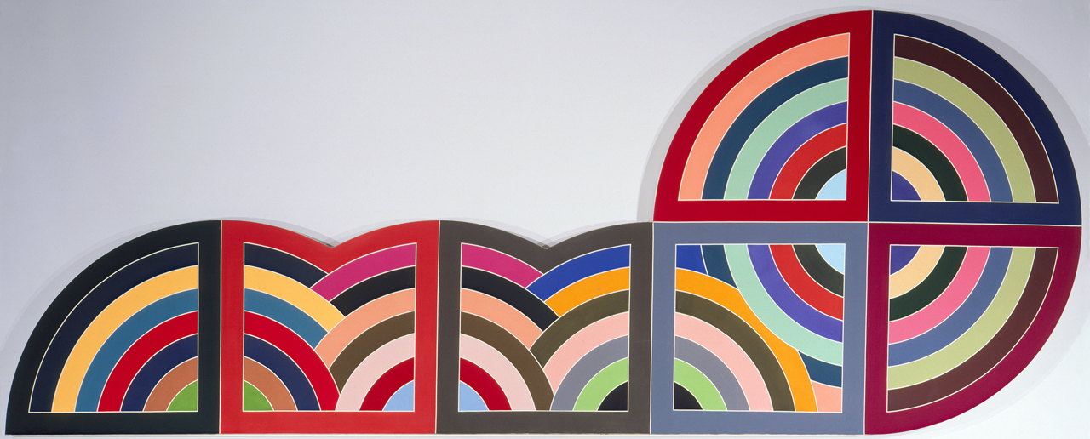
Frank Stella (American, born 1936)
Raqqa II
1970
Synthetic polymer and graphite on canvas
www.artnc.org/node/492

North Carolina Standards Correlations:
Math: 7.G.2, 7.G.4
Visual Arts: 7.V.3.1, 7.CX.2.2, 7.CR.1.1

Student Learning Objectives:
Students will demonstrate their knowledge of parts of circles and their relationships.
- Students will use appropriate tools to construct circles of given dimension.
- Students will find the circumference and area of the circles they construct.
- Students will analyze a work of art.
- Students will plan and create original works of art using the concentric circles.

Activities:
- Before beginning the lesson, students should be able to define and identify or calculate the following parts of a circle: center, radius, diameter, circumference, area, pi. They should know how to use a compass to construct a circle of a given radius.
- Review parts of a circle.
- Show Frank Stella’s Raqqa II and related works of art using the PowerPoint. Discuss:
What tools do you think Stella used to create his works of art? What kind of planning might have been involved in the creation of these works? Was precision important in making these pieces? What similarities and differences do you notice in the works in this series? What impact do color and placement of lines and shapes have on the overall design?
- Introduce the student project by showing a range of student products.
- Present students with the rubric, which will be used for self-assessment and formal assessment. Go over project requirements handout.
- Instruct students to draw concentric circles of given radii. They may construct four or more small paintings on heavy watercolor paper.
- Students record the radius of each of the circles on the handout.
- Students will color every other circle with crayon, and then paint the remaining circles with paint. Explain the crayon resist process (the paint will not “stick” to the crayon).
- Students will then cut each of the small paintings into two to four equal pieces.
- Students will arrange the pieces into a new design and then glue the pieces onto the large construction paper.
- Have students complete the self-assessment. As a class discuss the designs, and reflect on the role of planning and organization in art making.

Assessments:
- The self-assessment and handout will be used to evaluate students’ ability to find the radius, diameter, circumference, and area of the circles.
- Observation and student projects will demonstrate students’ ability to use proper tools and plan and organize works of art.
- Class discussion may be used to evaluate students’ ability to analyze a work of art.

Resources:
Vocabulary:
Radius
Circumference
Diameter
Area
Concentric
Circle
Compass
crayon resist
watercolor
pi
center

Materials:
Frank Stella PowerPoint
handouts
compasses
4x4 heavyweight watercolor paper
large construction paper (black works well)
rulers
watercolor sets
pencils
crayons
tape
erasers
water
cups
brushes

Math Project: Circle Art Inspired by the Protractor Series

NAME__________________________________

Radius:__________________________________________________

Diameter:________________________________________________

Concentric:_______________________________________________

What is the relationship between the radius and the diameter?______
________________________________________________________

What is the formula for area of a circle? ________________________

What is the formula for circumference? _________________________

What is the relationship between the circumference and the diameter?
________________________________________________________
Fill in the chart using measurements of circles you constructed:
Circle | Radius | Diameter | Area | Circumference
A
B
C
D
E
(Circle A will be the smallest)
Project Rubric

Project Aspect | Possible Points | Actual Points/Comments
The project is drawn according to specifications | 5
The project is neat | 5
The project shows craftsmanship | 5
The written work is accurate | 5
The calculations in the table are correct | 5

Points earned: _____________

X 4= Total Score:_____________

